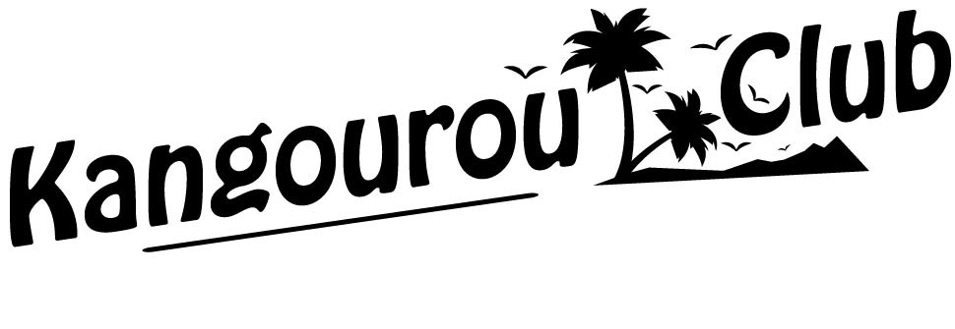
Family prices for 2019 with full board. Les Lindars Hotel Club, 3* rating.
Flaine. 1600m, Haute-Savoie near Geneva, Chamonix, Annecy…
The Top 3: entertainment- free activities- gourmet dining 29th
Price Per Person | AGE | Summer Dates 2019  possibility of staying Monday/ Monday for Israelis  Weekly stays or for 10/11 days (price proportional to the period)
 |  | 21-28/7 | 28/7-4/8 | 4-11/8 | 11-18/8 | 18-25/8 | 25/8-1/9
Northern bedroom | Adult | 450€ | 500€ | 450€ | 520€ | 520€ | 480€
Southern bedroom | Adult | 490€ | 530€ | 490€ | 560€ | 560€ | 500€
Children (whichever the room) | 10-14 years | 380€ | 400€ | 380€ | 410€ | 410€ | 410€
 | 6-9 years | 330€ | 350€ | 330€ | 350€ | 350€ | 350€
 | 2-5 years | 290€ | 290€ | 290€ | 290€ | 290€ | 290€
 | baby | free | free | free | free | free | free
Individual supplement |  | 100 € | 100 € | 100 € | 130 € | 130 € | 100€

General Conditions and Services:
- Les Lindars Hotel Club. The rooms have just been renovated and the bedding replaced. On the southern side are adjoining double rooms with a full view of the resort, each equipped with a bathroom (bathtub). These rooms are ideal for a family of 4 (couple + 2 children of more than 2 years old). On the northern side, rooms are available for 3 or 4 people, with 2 beds + 2 bunkbeds + bathroom with a shower).
- There are a few rooms available for people with limited mobility. There are 2 elevators on 7 floors. The hotel is situated in the heart of Flaine Forum, 20 meters away from the cinema and the 4* pool and spa complex.
- Hotel service every day except Shabbat. Towels provided.
- Rooms are available from 4pm on the day of arrival. Checkout is at 10/11am.
- Synagogue in the hotel, available for services, classes and lectures.
- Free Kangourou Club entertainment, provisional list subject to change:
- Free « Activities pass»: more than 20 free activities for everyone in the resort, from 3 years and up (see our site).
- Atmosphere and entertainment: Leisurely evenings and a club atmosphere are waiting for you. The hotel has a large lobby which looks out onto a full southern terrace and a big show hall. Karaoke evenings, Blind Test shows, singers and more.
- Free walking tours with a licenced guide from 28/07 to 28/08
- Krav Maga and Self Defence Courses + team sports activities from 14 to 28/8
- Mini Kangourou Club for children aged 2 to 14, Mondays to Fridays from 10am to 5.30pm. 65 € per week. On-site booking for 15 euros per day is possible, subject to availability.
- Mini club organised by the resort: free for 6-12-year olds. Bookings for half a day on site.
- Nursery for babies between 3 and 24 months old: 98 € package for 30 hours per week: from 1pm to 6pm then from 8pm to 9pm, every day from Monday to Friday.

- Terms of payment
- Baby crib on hire for the room: 17 € per week.
- Tourist tax: 0,75 € per night, per person above the age of 18.
- A deposit of 120 € per room will be requested of you upon your arrival and returned after inspection.
- Payment is via credit card or bank transfer.
- The prices include accommodation and full board. Stays begin from dinner on the day of your arrival and finish after breakfast on the day of departure. Entertainment is free and noncontractual.
- Adult stay without « activity pass »: 15 € reduction on weekly price.
- Accessibility
- Train access: Cluses station, and then a bus which leaves at 2.30pm and 6pm. Journey duration is approximately 40 minutes. Return bus at 10am (Sundays).
- Car access: very easy by motorway, then Cluses-Flaine on the main road is only 23 km. Free parking at the resort!
- Closest airport: Geneva airport is only 1.15 hours away, and then a car or taxi for up to 8 people can be hired to bring you to the resort. Ask us for more information.
- Taxi from Cluses railway station: 65 € for 1 to 4 people. 90 € for 5. Fereira taxi: 06 13 45 19 57
- Dining
- Fully Glatt Kosher board, under the supervision of Rav Yehouda Berdugo « atide-bh » kashrut certifier. Chalak Bet Yossef meat: Rav Cremisi, Rav Rottenberg. Poultry: Rav Rottenberg, Rav Cremisi or Rav Wolf. Dairy « chalav israel » Rav Pezner.
- We have chosen the best kashrut in order to allow the strictest clients to join us. The environment is friendly, familiar and relaxed. Whether you practise very little or are very strict, everyone finds their place in an atmosphere of mutual respect.
- Flaine 2019 with Kangourou Club: it’s the meeting place not to be missed!
All information can be found on our site: www.kangourouclub.com
Kangourou Club, at your service even on Sundays: 00 33 (0)4 88 91 60 54

